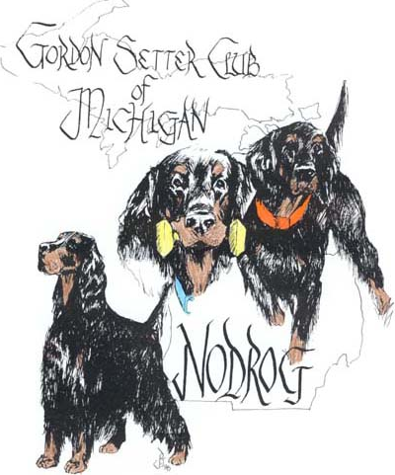
NODROG
GORDON SETTER CLUB OF MICHIGAN

2023 – 2024
AWARDS

Club Member: ______________________________________________________________

Reg. Name Dog: ___________________________________________________________

Dog’s Call Name___________________________________________________________

(Bar/Plaque)

Award: __________________________________ Date: _____________ __________

Award: __________________________________ Date: _____________ __________

Award: __________________________________ Date: _____________ __________

Events Worked At:

______________________________________________________ Date: ________________

______________________________________________________ Date: ________________

______________________________________________________ Date: ________________

Club member MUST work a minimum of THREE club events to be eligible for a
Free plaque and 1st initial bar
Additional Plaques and/or Additional Title Bars are at club members expense (please ask for price)
Awards will be awarded at Annual Picnic – July 2024
Awards may be mailed at owner’s expense
Deadline for submission - - - June 30, 2024
Mary Grill – 625 N. Force Rd. – Attica, MI 48412
Krystaless@hotmail.com

